**Smart Lock Analysis Report**

**Objective**: Circuit house is evaluating a potential entry in the Smart lock market. Since this is a fairly new category there are very few estimates present in terms of market size and key players. One way to estimate the key players is by looking at major brands on online portals.

**1. Number of brands in the segment**

There are 87 unique brands in the Smart Lock segment.

'atomberg', 'qubo', 'lavna', 'godrej', 'okos', 'plantex', 'speedy', 'uniy', 'yale', 'escozor', 'golens', 'valencia', 'denler', 'helett', 'grob', 'ozone', 'ifitech', 'qawachh', 'mars', 'delta', 'bonkaso', 'ironzon', 'nexmot', 'team', 'homemate', 'foora',

'gordej', 'daonphari', 'equal', 'dorset', 'bioenable', 'code', 'jal', 'unknown', 'bytbots', 'mx', 'triant', 'dorphin', 'hawkvision', 'ezviz', 'putmax', 'autens', 'tmezon', 'quba', 'tuchware', 'codace', 'lockly', 'leccy', 'houzmatic', 'inllex', 'fipilock', 'ghome', 'jenix', 'amicismart', 'ezlife', 'zkteco', 'abez', 'securam', 'geek', 'vizid', 'hafele', 'lockomatic', 'iplug', 'navkar', 'excluzo', 'gunally', 'realtime', 'wallton', 'delavala', 'folohaos', 'mukhivala', 'honexa', 'dhvaj', 'premvati','ketumal', 'ipsa', 'lacasa', 'jainson', 'olpad', 'iuknob', 'pulido', 'bolt.czar', 'ankh', 'losa', 'i-touch', 'rfid', 'blusafe'.

**2. Count of SKUs per brand**

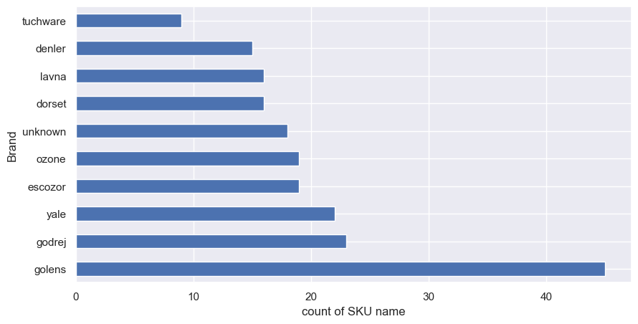

Insights: Around 45 products of Golens Brand are there in the dataset which is the highest number. Godrej, Yale, Escozor and ozone have 23, 22 and 19 products displayed in the website.

**Relative ranking and relative rating:**

**top 5 brands:**

Brand Relative Ranking Relative Rating

65 plantex 15.00 0.000

3 atomberg 24.40 4.720

71 qubo 27.75 4.325

82 valencia- 28.00 4.200

75 speedy 37.00 4.700

top 5 brands:

Brand Relative Ranking Relative Rating

2 ankh 342.0 0.0

56 losa 343.0 0.0

40 i-touch 346.0 0.0

73 rfid 348.0 0.0

6 blusafe 353.0 4.2

Insights:

Top 5 brands according to the relative ranking and relative rating are plantex, atomberg, qubo, valencia and speedy. Bottom 5 brands according to the relative ranking and relative rating are pankh, i-touch, losa, rfid and blusafe.

5. **Price distribution of SKUs**

Price Band

INR 5000-9999 89

INR 10000-14999 74

>INR 20000 69

<INR 2999 47

INR 15000-19999 44

INR 3000-4999 27

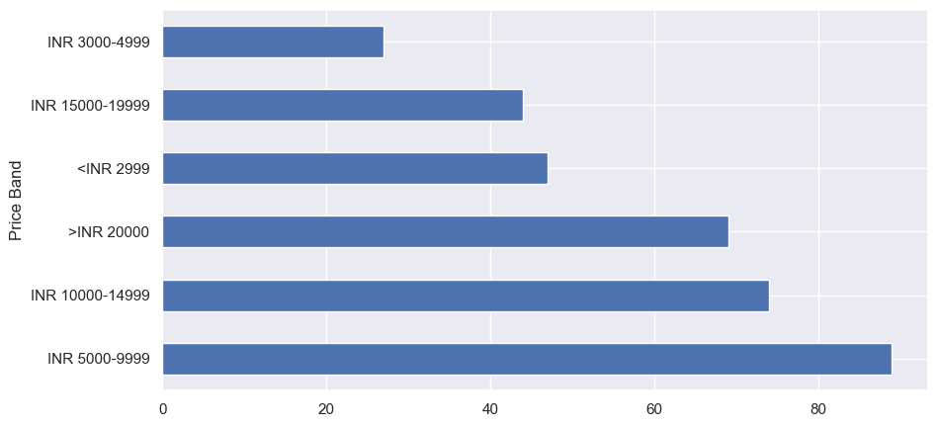

Insights: Price of 89 products lies in range (Rs. 5000-9999), 74 products lies in range (Rs. 10000,14999) and 69 products have price greater than Rs. 20000.

Conclusions:

1. There are 87 unique brands in the Smart Lock segment.
2. Golens Brand has the highest number of SKU count of 45 then, the SKU count of Godrej, Yale, Escozor and ozone have 23, 22 and 19.
3. Top 5 brands according to the relative ranking and relative rating are plantex, atomberg, qubo, valencia and speedy. Bottom 5 brands according to the relative ranking and relative rating are pankh, i-touch, losa, rfid and blusafe.
4. Highest number of products lie price range (Rs. 5000-9999).

Suggestions:

1. **Concentration of Brands**: With 87 unique brands in the Smart Lock segment, the market appears to be diverse but competitive. Circuit House should be prepared to face competition from established brands.

2. **Top Players**: Brands like **Plantex, Atomberg, Qubo, Valencia, and Speedy** are leading in both relative ranking and relative rating. These brands have likely established a strong market presence with well-performing products.

3. **High SKU Counts**: **Golens, Godrej, Yale, and Escozor** dominate the market with the highest number of SKUs. These brands likely have extensive product offerings, which could indicate a strong brand presence and consumer trust.

4. **Price Range Focus**: The majority of products fall within the **Rs. 5000-9999** price range. Circuit House could consider launching products in this price bracket to align with market demand and consumer expectations.

5. **Target Weak Spots**: The bottom-performing brands like **Pankh, i-Touch, Losa, RFID, and Blusafe** could indicate gaps in the market. Circuit House can study these brands to understand their shortcomings and potentially capitalize on these weaknesses.

6. To stand out, Circuit House should focus on creating a distinct value proposition that differentiates it from top brands like **Golens** and **Godrej**. This could involve innovation in features, superior customer service, or more competitive pricing.

7. Since the Smart Lock market is relatively new with limited estimates on market size, entering now could provide an opportunity for Circuit House to establish itself as a key player early on. The presence of a wide array of brands indicates market potential, but also necessitates a well-planned entry strategy.